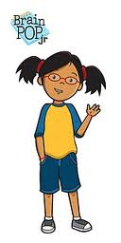
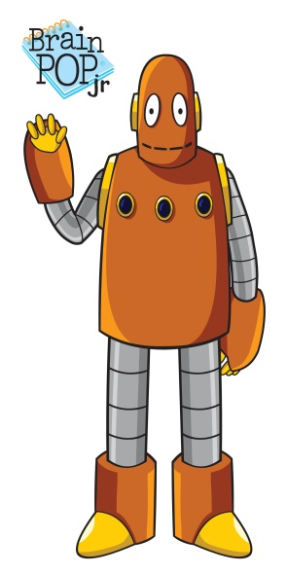
Name: ____________________ Webquest Graphic Organizer
Task 3: Magnet Attack!
Directions: Use the BrainpopJr. website to find the answers to
the following questions. Listen carefully!
1. What can magnets pull? ___________________________________
_____________________________________________________________
2. What can magnets not attract? ________________________________
___________________________________________________________________
3. What are magnetic poles? ______________________________________
___________________________________________________________________
4. What sides of the magnet will attract? ___________________________
___________________________________________________________________
5. What sides of the magnet will repel? _____________________________
___________________________________________________________________
6. What is a magnetic field? _______________________________________
___________________________________________________________________

Teacher Key:
1. What can magnets pull? Things that have iron in them: nuts screws or bolts, hammers, etc. NOT: soda cans, money,
2. What can mangets not attract? Paper, wood, plastic or rubber
3. What are magnetic poles? Where the pull of magnet is strongest. North pole and south pole
4. What sides of the magnet will attract? Opposite sides attract: North and South poles
5. What sides of the magnet will repel? Similar sides
6. What is a magnetic field? A magnetic field represents the force around a magnet.

