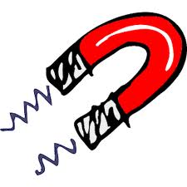
Magnet Poems and Song
Magnets
(Author Unknown)
I am a mighty magnet,
I can be very strong.
But if you use me exactly right
Nothing can go wrong.
I can pick up many objects
But not everything you see,
I only pick up objects
That are attracted to me.
So take me now and try me out
And you will quickly see,
What different kinds of things
Are pushed and pulled by me.

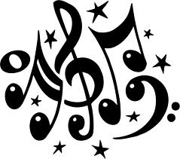
MAGNET SONG!
(Tune: Did you ever see a Lassie?)
Chorus:
Did you ever see a magnet, a magnet, a magnet?
Did you ever see a magnet pull this way and that?
On iron and steel, its pull is unreal!
Did you ever see a magnet pull this way and that?
Chorus
A magnet has action, it's called an attraction!
Did you ever see a magnet pull this way and that?
Chorus
Magnets Attract!
(Repeat each line after me!)
Magnets attract
That's a fact.
Things like nails
And metallic pails
Magnets attract
That's a fact.
Things like cars
And lids on jars.
Magnets attract
That's a fact
Things like pins
And cookie tins
Magnets attract
That's a fact!

